Monitor Settings
To change monitor settings, right click on your desktop and choose display settings.
Duplicated display
- You will have the same screen on your laptop, monitor, and SMARTboard.
- The SMARTboard tools and ink will only work on the SMARTboard if your monitors are set up this way.
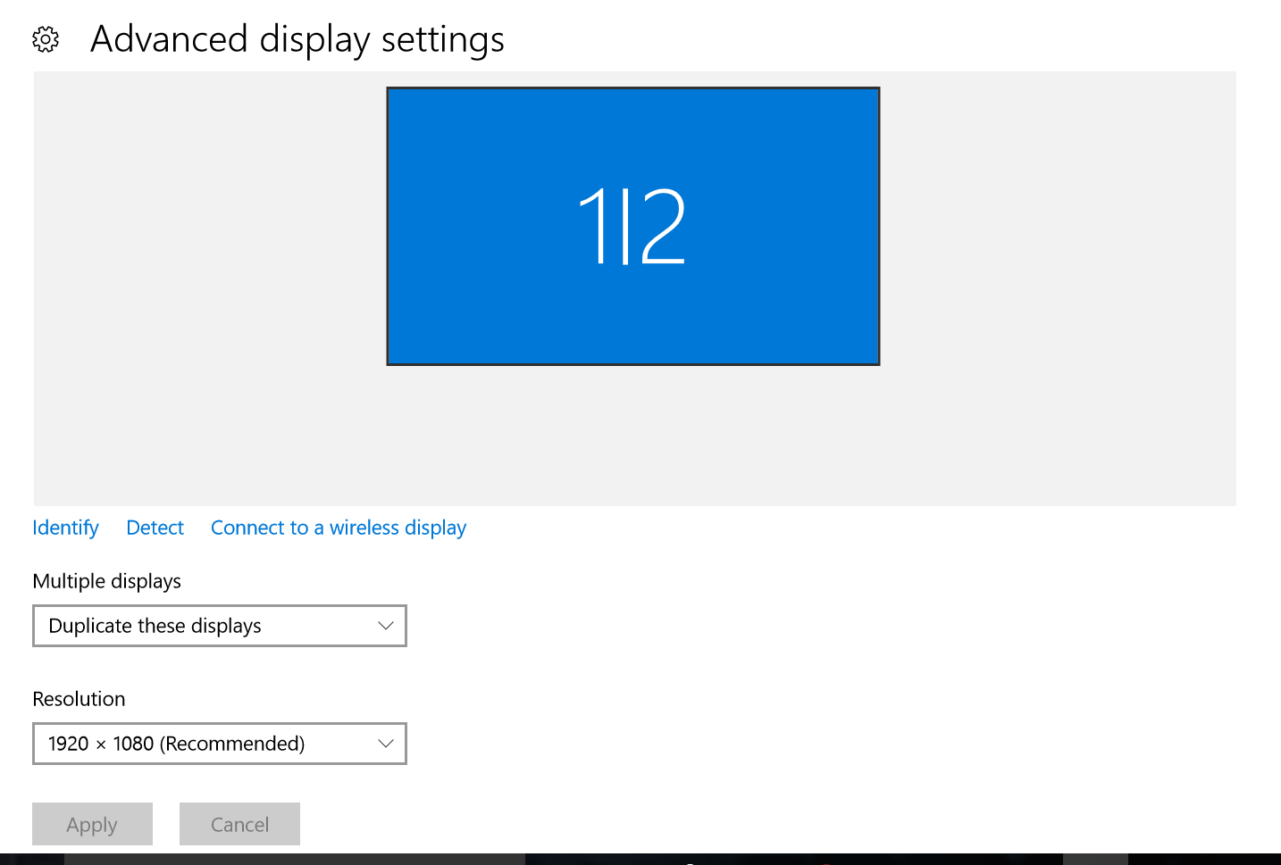
Choose “Duplicate these displays” and “Apply.”

Extended Monitors
- You will have an extended desktop showing different items on your laptop, monitor and/or SMARTboard.

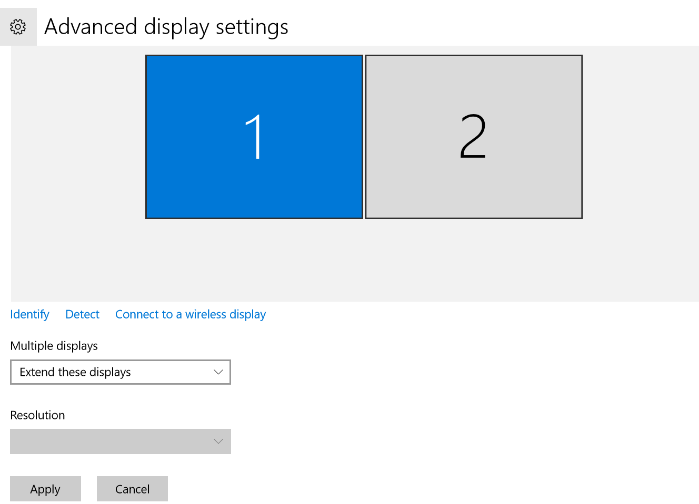

Choose “Extend these displays” and “Apply.”
- If your computer is set up a certain way (with the wiring), it will show three displays. Display 1 is always your laptop monitor. Display 2 and 3 can be either the SMARTboard or the stand alone monitor. You can have each with separate extended displays, or you can have, for example, display 1 (the laptop) as one screen and display 2 & 3 (the monitor and SMARTboard) duplicated and showing the same information on their screens.

Turning Off Laptop Monitor When Docked
- Some people prefer to turn off display 1 and only show the computer screen on the stand alone monitor when the laptop is docked.
- 